**DBMS LAB MANUAL**

Name: Mymoon Beevi.B Roll. No: 230701201

**Ex. No: 4:**

**Working with constraints**

1.ALTER TABLE EMP ADD CONSTRAINT my_emp_id_pk PRIMARY KEY(Employee_id); 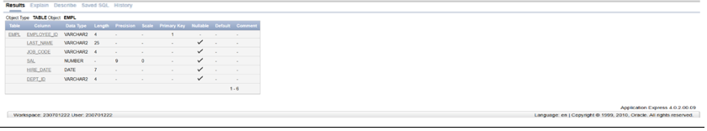

2. ALTER TABLE DEPT ADD CONSTRAINT creation PRIMARY KEY(ID); 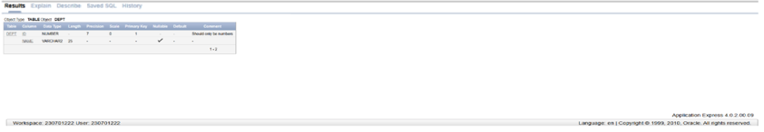

3. ALTER TABLE EMPL ADD DEPT_ID varchar(4);

ALTER TABLE EMPL ADD CONSTRAINT my_emp_dept_id_fk FOREIGN

KEY(DEPT_ID) references DEPT(ID);

4. ALTER TABLE EMPL ADD COMMISSION number(7);

ALTER TABLE EMPL modify COMMISSION number(2,2);

ALTER TABLE EMPL ADD CONSTRAINT com_check CHECK(commission&gt;0); 